### **Task Description**

Create a multi-step form using React where users can navigate through different sections, filling out the form step-by-step. Each step will have its own validation, ensuring that the user cannot proceed to the next step until the current step's input fields are correctly filled.

### **Task Output Screenshot**

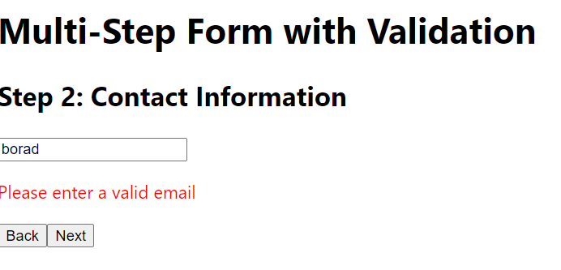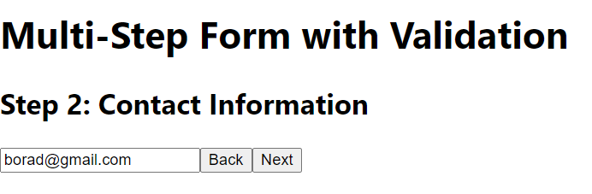

### **Widget/Algorithm Used in Task**

* **React Components**: The multi-step form is divided into multiple React functional components, each representing a step or section in the form.
* **useState Hook**:
  + Used to manage the current step of the form and store the input values from each step.
  + Each step’s form data is stored in a state object.
* **Form Validation**:
  + Each step has its own validation rules (e.g., required fields, email format, etc.).
  + Validation is performed before the user can proceed to the next step, using simple JavaScript logic or validation libraries like Yup or Formik.
* **Conditional Rendering**:
  + The form renders only one step at a time. Users can navigate between steps using "Next" and "Previous" buttons.
  + Conditional logic ensures that only valid data allows users to move forward.
* **useEffect Hook**:
  + Optionally used to save form data to local storage or sync it with a backend API to persist progress between sessions.
* **Progress Indicator**: A progress bar or step indicator is added to visually show the user which step they are currently on and how many steps remain.
* **Next/Previous Buttons**:
  + "Next" button advances to the next step if the validation passes.
  + "Previous" button allows the user to go back to the earlier steps to review or edit the inputs.
* **CSS**: Used for styling the form, making the transition between steps smooth and visually appealing.